**DBS LAB PROJECT**

**BLOOD DONATION**

**DATABASE**



**Team members:**

|  |  |  |
| --- | --- | --- |
| **NAME** | **ROLL NO** | **REG NO** |
| **Pallabi Chandra** | **11** |  |
| **Abirami Byju** | **31** |  |
| **Anusha Prabhu** | **2** |  |

**Cse 4th sem Sec:A**

Contents

1. Abstract 3

2. Problem Statement 3

3. ER Diagram 5

4. Relational Table with Sample Data 6

5. DDL Commands 7

6. List of Queries 11

7. UI Design 11

8. Pseudocode 15

9. Reference 22

# Abstract

The aim of this project is to create a website to facilitate blood donation especially for the student and faculty of Manipal University. The website will allow registration of donors and recipients. Once the blood is donated a record is stored in the data base. The recipient is then given the appropriate transfusion based on the blood types and bags available.

# Problem Statement

The website is designed using the following components:

|  |  |  |
| --- | --- | --- |
| slno | component | usage |
| 1 | MySQl | Backend database |
| 2 | PHP | Server side script(establishes connection to database) |
| 3 | HTML | Webpage design |
| 4 | Apache | Application server |

The front end website will have the following options-

* Homepage,
* Become donor,
* Donate blood,
* Recipient,
* Get blood,
* Donor list.

**Become donor :** Registers the donors by capturing the details of the donor and stores the donor record in a donor relation. The DonorId (automated slno) is generated when the record is saved and this is the primary key (unique value to identify each tuple).

**Recipient:** Registers the recipient by capturing the details of the recipient and stores the recipient record in a recipient relation. The RecipientId (automated slno) is generated when the record is saved and this is the primary key (unique value to identify each tuple).

**Donate blood:** Allows donor to donate blood and records the bagcode in donorbloodbag relation(with the ‘available’ attribute = ’Y’). Bloodbag code has to be unique and serves as a primary key.

**Get blood:** Allows recipient to receive blood using the bags available(those bags which have ‘available’ as’Y’ )and records the bagcode in recipientbloodbag relation(available attribute for chosen blood bag updated to ‘N’ in donorbloodbag). Once the available becomes ‘N’ the blood bag will not be available for picking in future.

**Donor list:** gives us a list of all donors in the database along with their details in slno order of registration. This also allows us to deregister a donor if the delete icon is pressed. Correspondingly that record is deleted in database. The slnos in the display page are updated accordingly.

# ER Diagram

# Relational Table with Sample Data

Donor relation

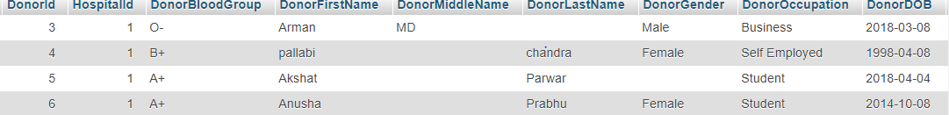

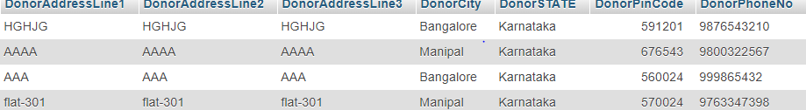

Recipient relation





Donorbloodbag relation

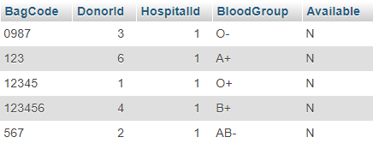

Recipient bloodbag relation

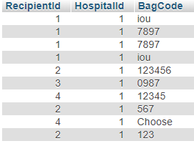

Hospital backend record



# DDL Commands

**Donor table:**

CREATE TABLE donor (

`DonorId` int(10) NOT NULL primary key,

`HospitalId` int(10) NOT NULL,

`DonorBloodGroup` varchar(5) DEFAULT NULL,

`DonorFirstName` varchar(20) NOT NULL,

`DonorMiddleName` varchar(20) DEFAULT NULL,

`DonorLastName` varchar(20) DEFAULT NULL,

`DonorGender` varchar(10) DEFAULT NULL,

`DonorOccupation` varchar(30) DEFAULT NULL,

`DonorDOB` date DEFAULT NULL,

`DonorAddressLine1` varchar(100) NOT NULL,

`DonorAddressLine2` varchar(100) DEFAULT NULL,

`DonorAddressLine3` varchar(100) DEFAULT NULL,

`DonorCity` varchar(30) DEFAULT NULL,

`DonorSTATE` varchar(30) DEFAULT NULL,

`DonorPinCode` int(10) DEFAULT NULL,

`DonorPhoneNo` varchar(12) DEFAULT NULL,

Foreign key(Hospitalid) references Hospital(Hospiatalid)

);

Sample data:

INSERT INTO donor values(1, 1, 'O+', 'Suprada', 'S', '', 'Male', 'Teacher’, '2018-04-04', 'odihfe', 'odihfe', 'odihfe', 'Bangalore', 'Karnataka', 591201, '');

INSERT INTO donor values(2,1 'B+', 'pallabi', '', 'chandra', 'Female', 'Student', '1998-04-08', 'AAAA', 'AAAA', 'AAAA', 'Manipal', 'Karnataka', 676543, '9800322567');

Donor blood bag:

CREATE donorbloodbag (

`BagCode` varchar(10) primary key,

`DonorId` int(10) NOT NULL,

`HospitalId` int(10) NOT NULL,

`BloodGroup` varchar(5) DEFAULT NULL,

`Available` char(1) DEFAULT NULL,

Foreign key(DonorId) references Donor(DonorID),

Foreign key(HospitalId) references Hospital(HospitalId)

) ;

SAMPLE DATA:

INSERT INTO donorbloodbag VALUES('0987', 1, 1, 'O-', 'N');

INSERT INTO donorbloodbag VALUES ('1234', 2, 1, 'O+', 'Y');

RECIPIENT TABLE:

CREATE TABLE recipient (

`RecipientId` int(10) PRIMARY KEY,

`HospitalId` int(10) NOT NULL,

`RecipientFirstName` varchar(20) NOT NULL,

`RecipientMiddleName` varchar(20) DEFAULT NULL,

`RecipientLastName` varchar(20) DEFAULT NULL,

`RecipientGender` varchar(10) DEFAULT NULL,

`RecipientBloodGroup` varchar(5) DEFAULT NULL,

`DonorOccupation` varchar(30) DEFAULT NULL,

`RecipientDOB` date DEFAULT NULL,

`RecipientAddressLine1` varchar(100) NOT NULL,

`RecipientAddressLine2` varchar(100) DEFAULT NULL,

`RecipientAddressLine3` varchar(100) DEFAULT NULL,

`RecipientCity` varchar(30) DEFAULT NULL,

`RecipientSTATE` varchar(30) DEFAULT NULL,

`RecipientPinCode` int(10) DEFAULT NULL,

`RecipientPhoneNo` varchar(12) DEFAULT NULL,

Foreign key(HospitalId) references Hospital(HospitalId)

) ;

SAMPLE DATA:

INSERT INTO recipient VALUES(1, 1, 'Andy', 'M', 'L', 'Male', 'B-', 'Public ,’student’, '2018-03-02', 'HJKH', 'JKHKJH', 'JHKJH', 'Shimogha', 'Karnataka', 741852, '9874563210'),

INSERT INTO recipient VALUES( (3, 1, 'mandy', 'j', 'h', 'Female', 'O-', 'student', '2018-03-01', 'jkhkjh', 'jhkh', 'jkhjk', 'MANIPAL', 'Karnataka', 987456, '9874563012');

RECIPIENT BLOOD BAG:

CREATE TABLE `recipeintbloodbag` (

`RecipientId` int(10) NOT NULL,

`HospitalId` int(10) NOT NULL,

`BagCode` varchar(10) PRIMARY KEY,

Foreign key(HospitalId) references Hospital(HospitalId),

Foreign key(Bagcode) references Donorbloodbag(Bagcode),

Foreign key(RecipientId) references Recipient(RecipientId)

) ;

SAMPLE DATA:

INSERT INTO recipeintbloodbag VALUES (2, 1, '1234'),

INSERT INTO recipeintbloodbag VALUES (3, 1, '0987');

HOSPITAL :

CREATE TABLE hospital (

`HospitalId` int(10) PRIMARY KEY,

`HospitalLicNo` int(10) NOT NULL,

`HospitalName` varchar(50) NOT NULL,

`AddressLine1` varchar(100) NOT NULL,

`AddressLine2` varchar(100) DEFAULT NULL,

`AddressLine3` varchar(100) DEFAULT NULL,

`City` varchar(30) DEFAULT NULL,

`StateName` varchar(30) DEFAULT NULL,

`PinCode` int(10) DEFAULT NULL,

`PhoneNo` varchar(12) DEFAULT NULL,

`ContactName` varchar(30) DEFAULT NULL

)

SAMPLE DATA:

INSERT INTO HOSPITAL VALUES(1,123,’KMC’,’CCC’,’CCC’,’CCC’,’MANIPAL’.’KARNATAKA’,’570064’,’66558988’,;RECEPTION’);

Note: address lines and dates of birth are dummy values

# List of Queries

UPDATE donorbloodbag SET Available='N' WHERE BagCode='recp_bagcode'; /* recp_bagcode is the value passed from the UI */

select * from donor;

delete from donor where DonorId='del’; ; /* del is the value of the donorid passed from the UI */

# UI Design

**HOME PAGE:**

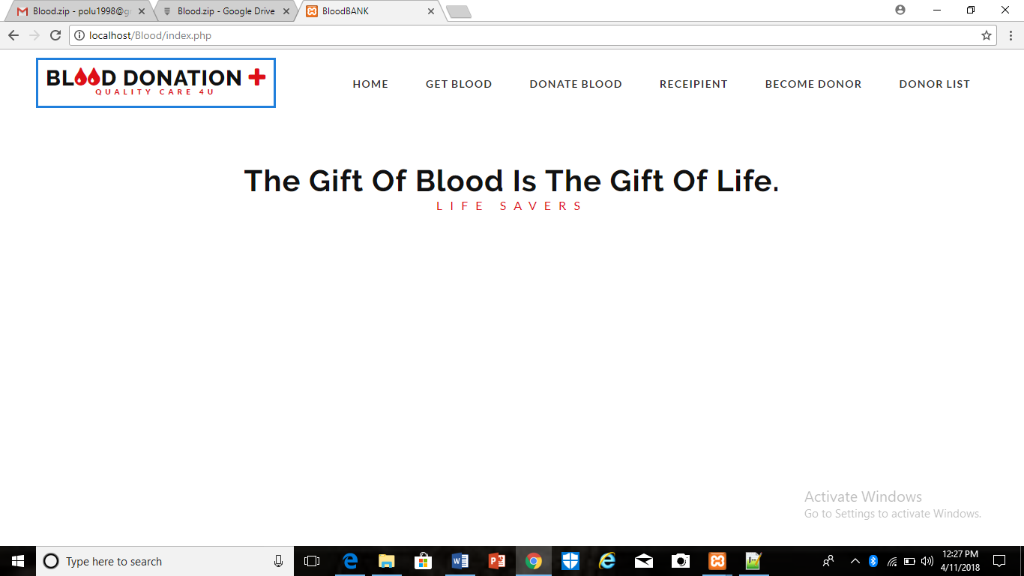

Become donor(registration):

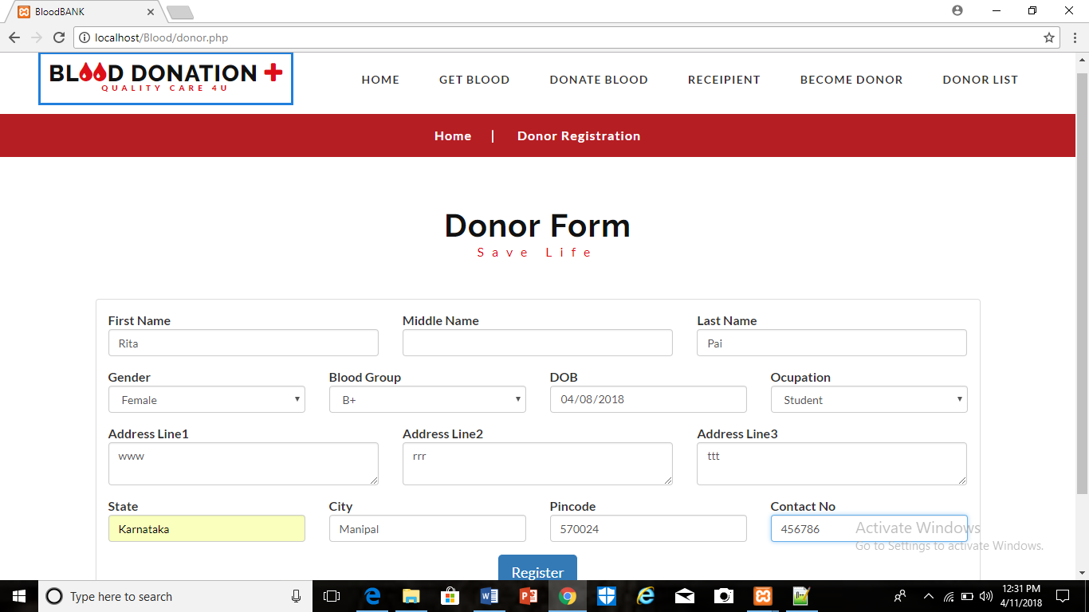

Recipient registration:

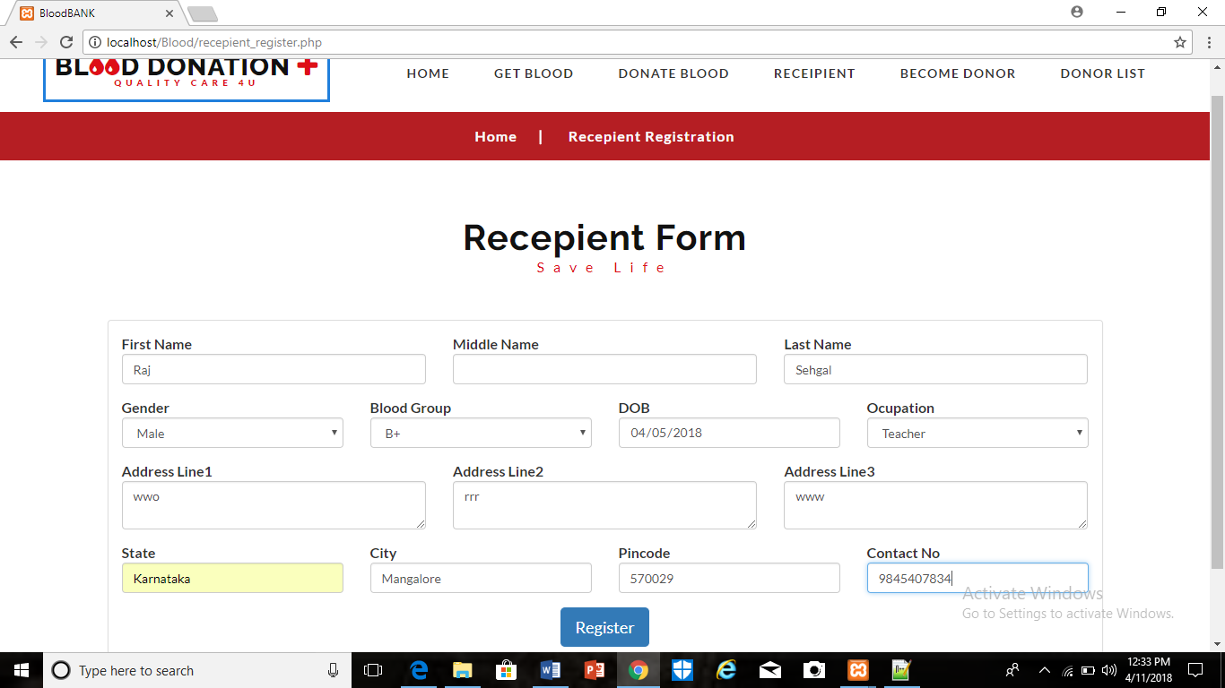

Donate blood:

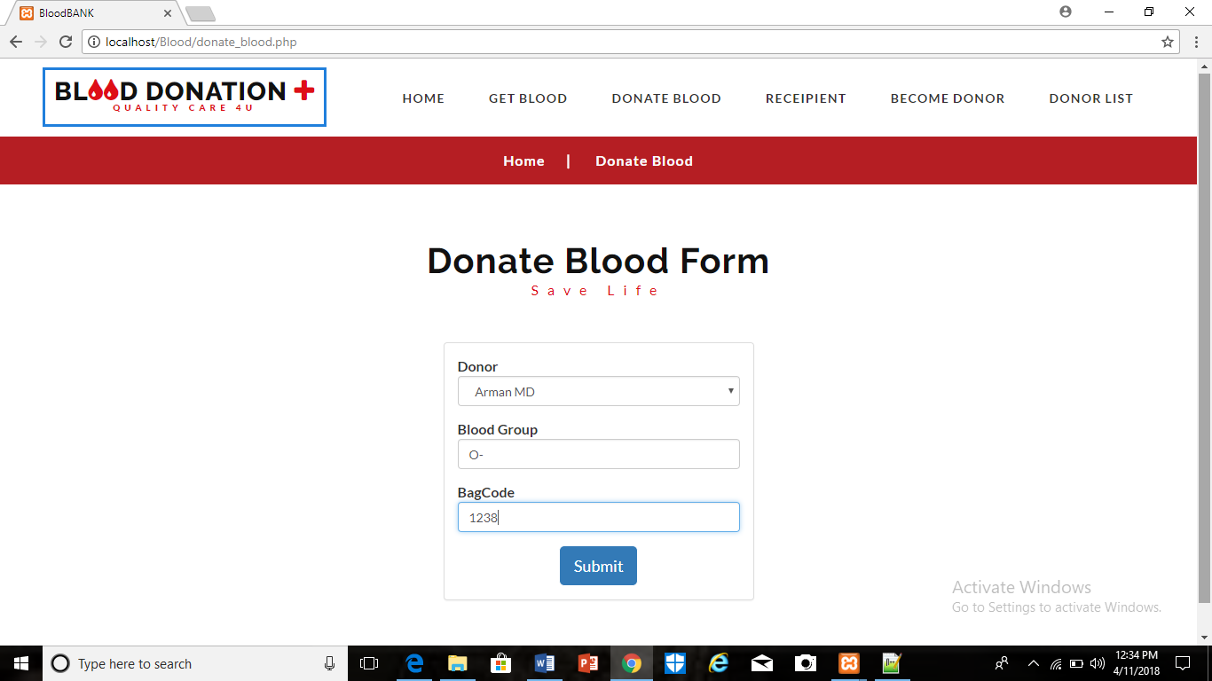

Recipient receives blood:

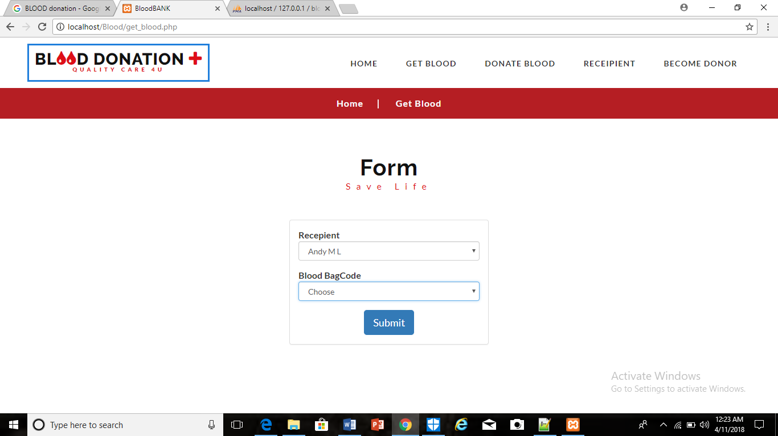

Displaying donor list:

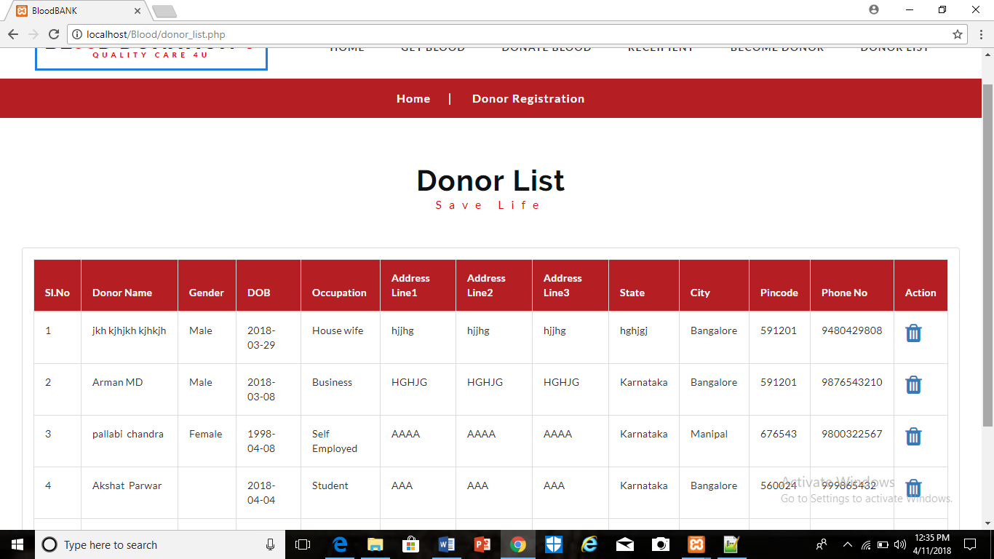

Deleting a donor

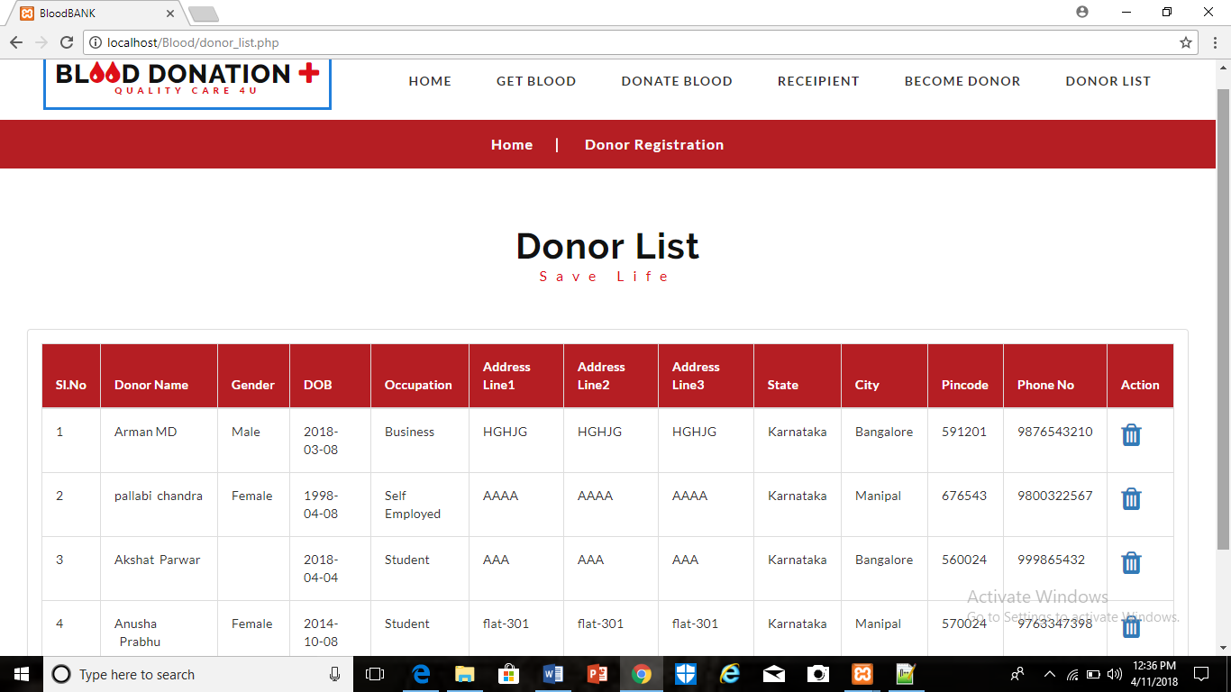

Donor 1 is deleted on pressing symbol.

# Pseudocode

BASIC DATABASE CONNECTIVITY(db.config)

<?php

$conn = mysqli_connect("localhost","root","","bloodbank");

/* localhost is the name of the server

root is the db userid

“” since there is no password set for the userid root

bloodbank is the name of the database

?>

TO INSERT RECORDS INTO RECIPIENT

<?php

$recp_fname=$_POST['Recpfname'];

$recp_mname=$_POST['Recpmname'];

$recp_lname=$_POST['Recplname'];

$recp_gender=$_POST['Recpgender'];

$recp_bgroup=$_POST['Recpbloodtype'];

$recp_occupation=$_POST['Recpoccupation'];

$recp_dob=$_POST['Recpdob'];

$recp_adrrl1=$_POST['Recpaddrl1'];

$recp_addrl2=$_POST['Recpaddrl2'];

$recp_addrl3=$_POST['Recpaddrl3'];

$recp_city=$_POST['Recpcity'];

$recp_state=$_POST['Recpstate'];

$recp_pcode=$_POST['Recppincode'];

$recp_phno=$_POST['Recpcontact'];

/* the values in the UI screen are passed to the PHP program */

include("dbconfig.php");// connect to database

/* conneting to the database */

$sql_insert="INSERT INTOO recipient

(HospitalId, RecipientFirstName,RecipientMiddleName,RecipientLastName,

RecipientGender,RecipientBloodGroup,DonorOccupation,RecipientDOB,

RecipientAddressLine1,RecipientAddressLine2,RecipientAddressLine3,

RecipientCity,RecipientSTATE,RecipientPinCode,RecipientPhoneNo)

VALUES ('1','$recp_fname','$recp_mname','$recp_lname','$recp_gender','$recp_bgroup','$recp_occupation','$recp_dob','$recp_adrrl1','$recp_addrl2','$recp_addrl3','$recp_city','$recp_state','$recp_pcode','$recp_phno')";

$status = mysqli_query($conn,$sql_insert);

if($status==true)

{

header('location:recepient_register.php');

}

else

{

header('location:recepient_register.php');

}

/* In case we had an error page then for error condition the respective page will open */

?>

TO INSERT RECORD TO RECIPIENTBLOODBAG:

<?php

$recp=$_POST['Recp'];

$recp_bagcode=$_POST['Recpbagcode'];

/* the values in the UI screen are passed to the PHP program */

include("dbconfig.php");

$sql_insert="INSERT INTO recipeintbloodbag (RecipientId,HospitalId,BagCode) VALUES ('$recp','1','$recp_bagcode')";

$status = mysqli_query($conn,$sql_insert);

if($status==true)

{

$sql_update = "UPDATE donorbloodbag SET Available='N' WHERE BagCode='$recp_bagcode'";

$stat = mysqli_query($conn,$sql_update);

if($stat==true)

{

header('location:get_blood.php');

}

}

else

{

echo $status;

}

?>

TO INSERT RECORD IN DONOR:

<?php

$donor_blood_group = $_POST['bloodtype'];

$donor_fname = $_POST['fname'];

$donor_mname = $_POST['mname'];

$donor_lname = $_POST['lname'];

$donor_gender = $_POST['gender'];

$donor_occupation = $_POST['occupation'];

$donor_dob = $_POST['dob'];

$donor_addrline1 = $_POST['addrline1'];

$donor_addrline2 = $_POST['addrline1'];

$donor_addrline3 = $_POST['addrline1'];

$donor_city = $_POST['city'];

$donor_state = $_POST['state'];

$donor_pincode = $_POST['pincode'];

$donor_phone = $_POST['contact'];

include("dbconfig.php");

$sql= "insert into donor

(HospitalId,DonorBloodGroup,DonorFirstName,DonorMiddleName,DonorLastName,DonorGender,DonorOccupation,DonorDOB,DonorAddressLine1,DonorAddressLine2,DonorAddressLine3,DonorCity,DonorSTATE,DonorPinCode,DonorPhoneNo)

Values

(1,'$donor_blood_group', '$donor_fname', '$donor_mname', '$donor_lname', '$donor_gender','$donor_occupation', '$donor_dob', '$donor_addrline1','$donor_addrline2','$donor_addrline3','$donor_city','$donor_state','$donor_pincode','$donor_phone')";

$status = mysqli_query($conn,$sql);

if($status==true)

{

header('location:donor.php');

}

else

{

header('location:donor.php');

}

?>

TO INSERT RECORD IN DONORBLOODBAG:

<?php

session_start();

if(isset($_SESSION['msg']))

{

echo $_SESSION['msg'];//print

unset($_SESSION['msg']);//delete

}

$donor_bagcode = $_POST['bag_code'];

$donor_id = $_POST['donor_name'];

$donor_bloodgroup = $_POST['blood_group'];

// echo $donor_bloodgroup;

include("dbconfig.php");

$sql= "insert into DonorBloodBag

(BagCode,DonorId,HospitalId,BloodGroup,Available)

values('$donor_bagcode', '$donor_id', '1', '$donor_bloodgroup', 'Y')";

$status = mysqli_query($conn,$sql);

if($status==true)

{

header('location:donate_blood.php');

}

else

{

header('location:donate_blood.php');

}

?>

To display donor list

<?php

include("dbconfig.php");

$sql = "select * from donor";

$res = mysqli_query($conn,$sql);

$total = mysqli_num_rows($res);

if($total>0)

{

$i=1;

while($row = mysqli_fetch_object($res))

{

echo "<tr>

<td>$i</td>

<td>$row->DonorFirstName&nbsp;$row->DonorMiddleName&nbsp;$row->DonorLastName</td>

<td>$row->DonorGender</td>

<td>$row->DonorDOB</td>

<td>$row->DonorOccupation</td>

<td>$row->DonorAddressLine1</td>

<td>$row->DonorAddressLine2</td>

<td>$row->DonorAddressLine3</td>

<td>$row->DonorSTATE</td>

<td>$row->DonorCity</td>

<td>$row->DonorPinCode</td>

<td>$row->DonorPhoneNo</td>

<td><a href='delete_donor.php?id=$row->DonorId'><i class='fa fa-trash fa-2x'></i></a></td>

</tr>";

$i++;

}

}

?>

To delete donors from donor list

<?php

include('dbconfig.php');

$del = $_REQUEST['id'];

$sql = "delete from donor where DonorId='$del'";

mysqli_query($conn,$sql);

header('location:donor_list.php');

?>

# Reference

1. <https://www.w3schools.com/php/php_mysql_connect.asp>
2. <https://www.slideshare.net/Rprasad1/blood-donation-ppt-67420666>
3. <http://www.phpknowhow.com/basics/working-with-xampp/>
4. DATA BASE SYSTEMS AND CONCEPTS 6TH EDITION Abraham Silberschatz ,Henry F. Korth Lehigh ,S. Sudarshan